Name: Phuc Le

Course: CS146

Date: 12/14/17

Report Programming Assignment 3

1. Key concepts of this programming design.
2. Implement Red Black Tree data structure to manage patients in a hospital waiting room.
3. Red Black Tree is a very efficient data structure that guarantee the basic activities with its run with log(n) complexity.
4. Red Black Tree can keep the current Tree of patient approximately balanced at all time so that all activities related such as Search, Insertion or Deletion would take approximately log(n) complexity.
5. Simulating normal activities in a waiting room by using Red Black Tree methods.
6. Find a Patient with a given condition. Delete a patient with a given condition. Insert a patient into the current Queue.
7. This program gives User a friendly User Interface that allow them to do all the basic operation with a waiting room in the Hospital.
8. Classes:
9. Patient

* Purpose: Object the contain patient’s information help manage patient more effective.
* Attribute:
  + Name: contain name of the patient.
  + Condition: contain current condition of the patient. (The greater the number, the higher priority).
  + Constructor: Two constructor.
    - Take in no information.
    - Take in name and condition of patient.
* Method:
  + getName: Return name of patient.
  + getCondition: Return current condition of patient.
  + setName: set the name of patient.
  + setCondition: set the condition of patient.
  + getInfo: return all information of a patient including name and condition.

1. Node<Patient>

- Purpose: This is the “Node” object used in the binary search tree.

- Attribute:

* + Data: contain the Patient object.
  + Left: the child Node.
  + Right: the right child Node.
  + color: Contain the color of the Node.

- Methods:

* + toString: return the patient object information.
  + setRight: set the right children.
  + setLeft: set the left children.
  + setP: set parent.
  + Constructor: Three constructor.
    1. Take in no information
    2. Take in Data(Patient)
    3. Take in Data(Patient), left, right, p.

1. MyComparator

- Purpose: Comparator class used to compare the 2 nodes base on the condition of the patient object inside it.

1. RBT

- Purpose: This is the Red Black Tree Class modified to fit the waiting room activities.

- Attribute:

* + root: the root of the tree.
  + Nil node: nil node which has “black” color.
  + Comparator: comparator instance of comparator class.

- Method:

* + compare: compare 2 patients base on their condition.
  + TreeMinimum: return the minimum condition patient given the root of that tree.
  + TreeMaximum: return the maximum condition patient given the root of that tree.
  + Search: Search for a specific Node that contain a patient with a given condition. This method takes in the root of that tree and condition.
  + InorderTreeWalk: this method prints the patient in the tree out ascendingly base on their condition.
  + RBInsert: Insert a new node into the current tree. This insert method is modified to help maintain the property of the Red Black Tree.
  + LeftRotate: This method does the left rotate of the given node, help maintaining the property of Red Black Tree when performing insertion and deletion.
  + RightRotate: This method does the right rotate of the given node, help maintaining the property of Red Black Tree when performing insertion and deletion.
  + RBInsertFixup: This method is to fix any violations when insert a new node into the current Red Black Tree.
  + Transplant: Transplant method modified to work with Reb Black Tree.
  + RBDelete: delete a given node from the Red Black Tree and help maintain the property of that Red Black Tree.
  + RBDeleteFixup: Method help fix any violations when delete a node from the Red Black Tree.

1. HW3

- Purpose: Main running class for hospital waiting room using Red Black Tree, which demonstrating the activities of a waiting room using basic Red Black Tree function activities such as Insert, Delete, Find and Sort.

* Attribute:
  + name: array of random distinct names.
  + A: array contain the distinct number used for creating distinct patient condition.
  + Patients: array of Object Patient.
  + RBT: instance of the RBT class.
  + currentUsedIndex: variable used to keep track of the usage of name in the name array. (Which make sure that we don’t have two patients with the same name.)
  + currentOccupiedSeat: Keep track of number of patients in the queue at the moment.
* Method:
  + RandomAPatient: Random a distinct patient with distinct name and condition.
  + RandomPatientsTree: Random an array of distinct patients and insert them into the Red Black Tree.
  + Print: Function use to print the current Patient in the Red Black Tree in ascending order base on the patient condition using the InOrderTreeWalk method.
  + GetCondition(String a): Get input condition to delete or find a patient passing a parameter to get more information(a = “find” or “delete”).

1. Screenshots and procedure to verify this code.

- After opening the file in terminal This window appears:

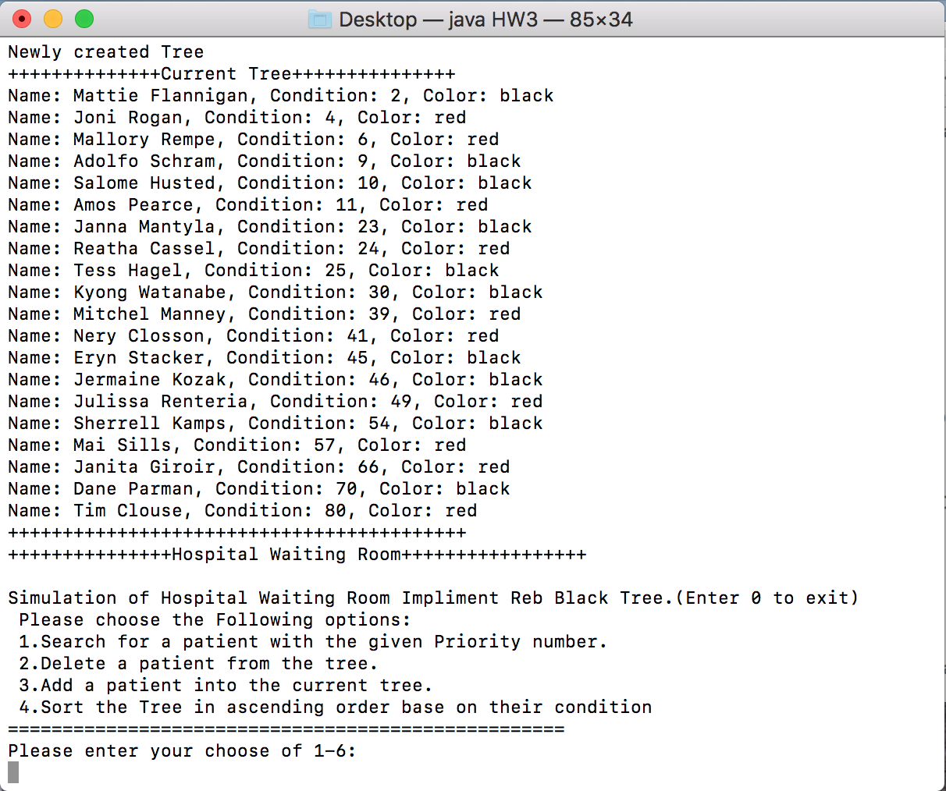

* The Program will first Create a random List of Patient with distinct name and distinct condition. Then create a Red Black Tree Base on the patient condition.
  + 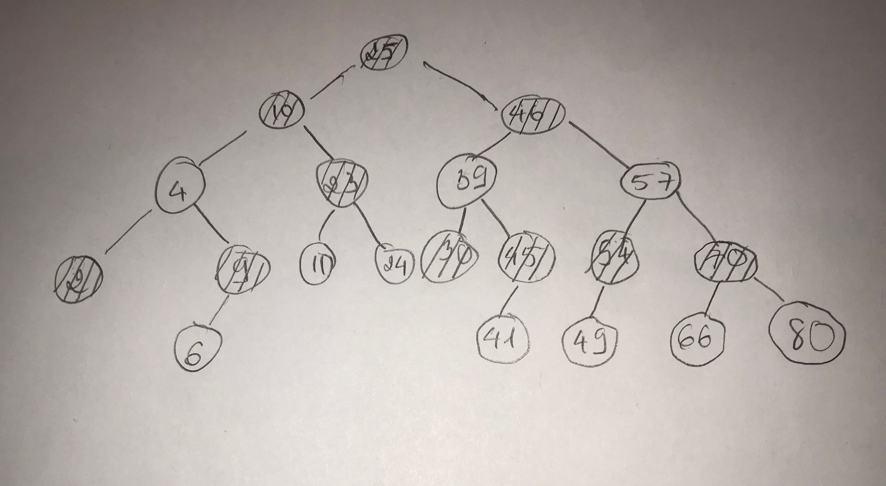In this example, the Current Tree can be drawn as follow:
* 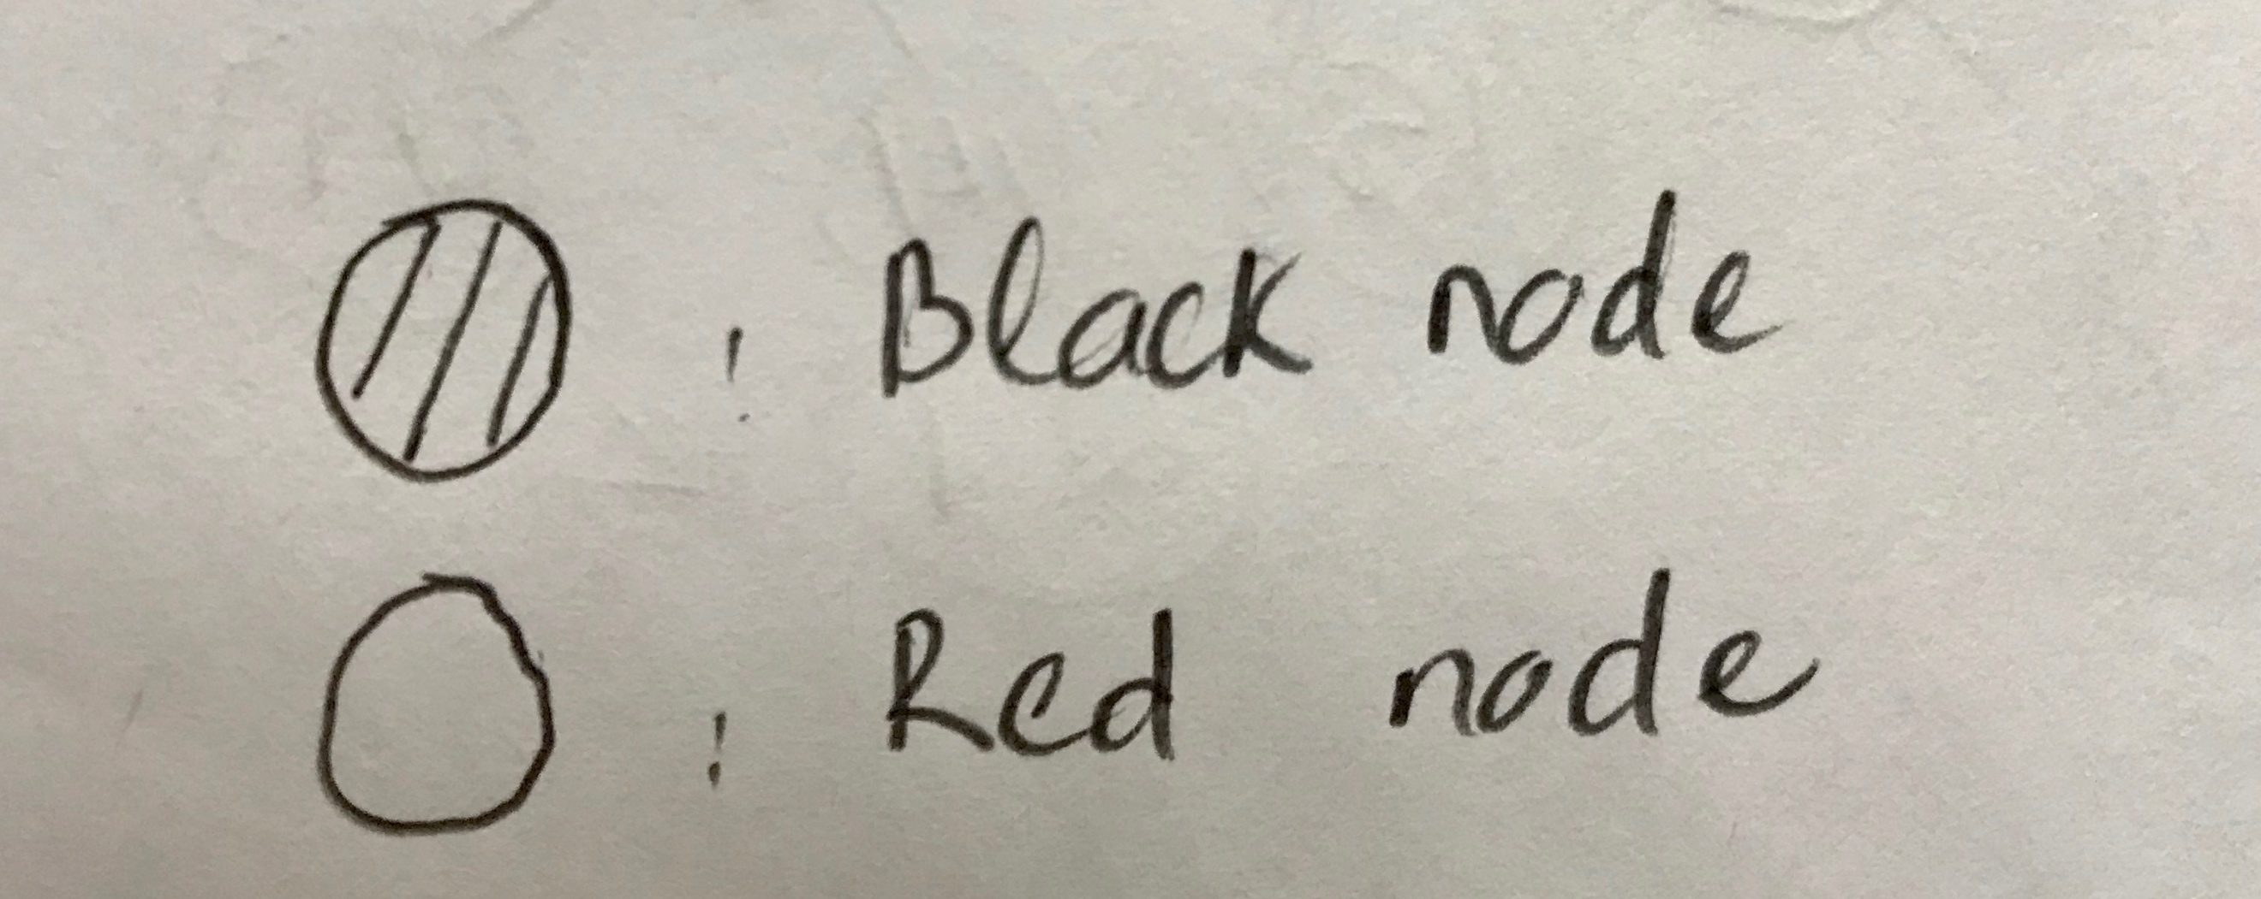Then, User can Choose the 4 options from the menu.
* If 1 is selected:
  + User will be asked for a valid condition to search for patient name.
  + 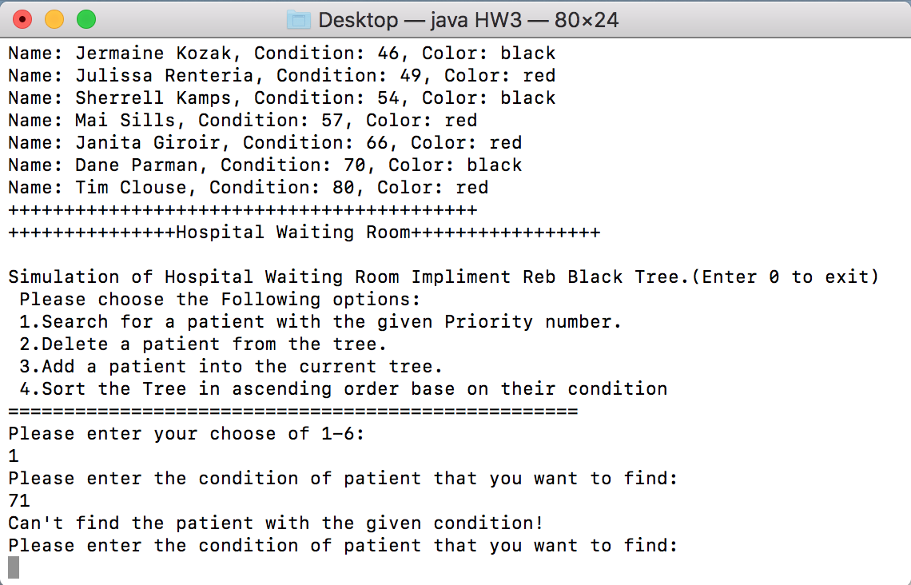If User enter an invalid condition, the program will then prompt that “Can’t find any patient with the given condition”. Then User can enter another condition to search.
* 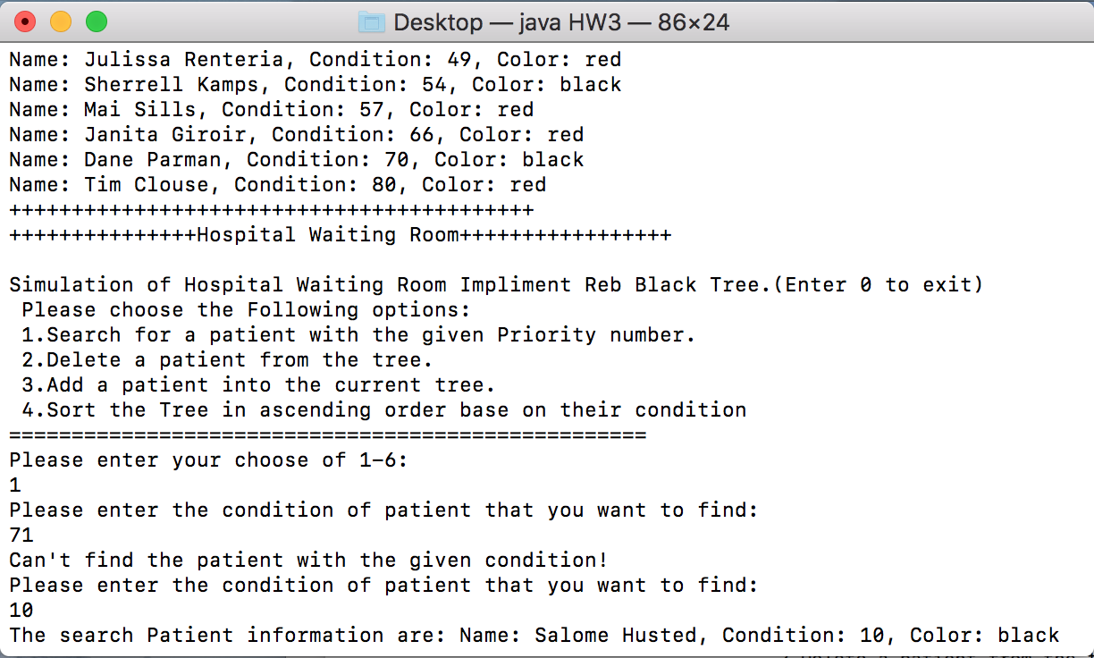After input a valid condition, the program will print out the Information of the patient including the Name, Condition the color.
* If the user choose option 2. The user will be asked for the condition of the patient that is going to be deleted.
  + The program will also prompt user when an invalid condition is entered.
  + If a valid condition has been entered the program will print the information of the found patient and the current tree after deleting that patient:
  + Test delete 1st time: delete 46.

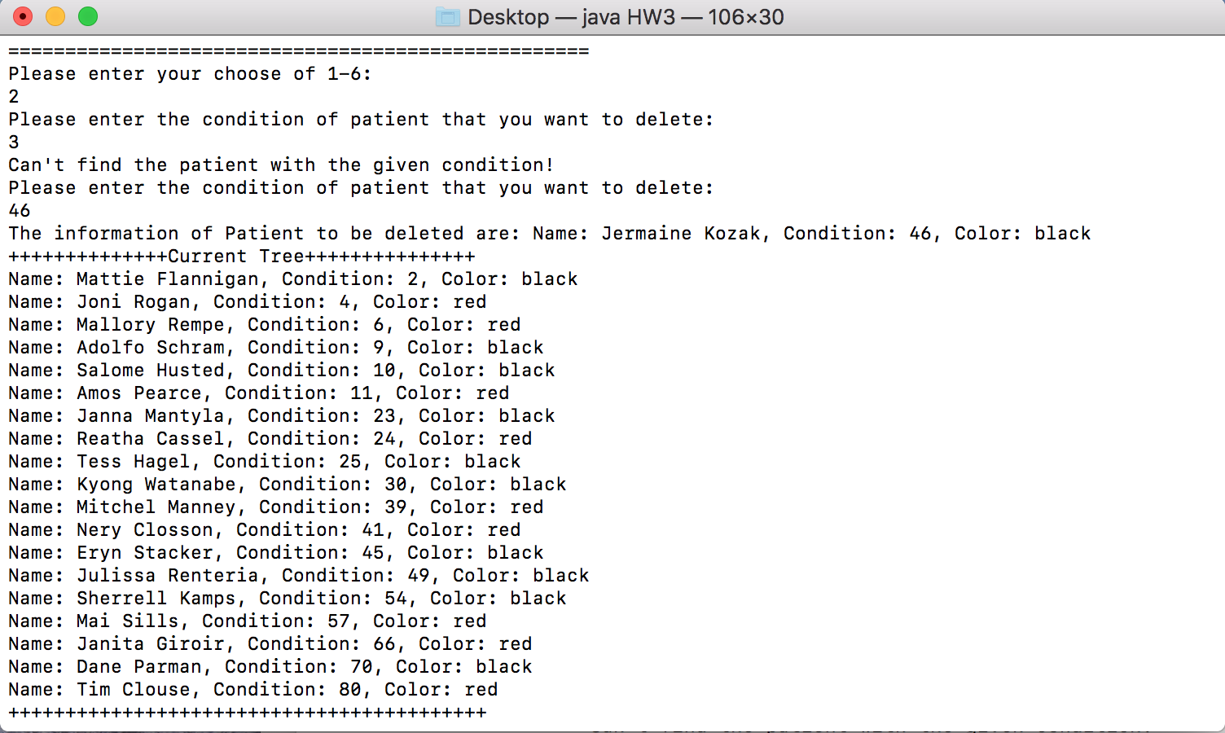

* 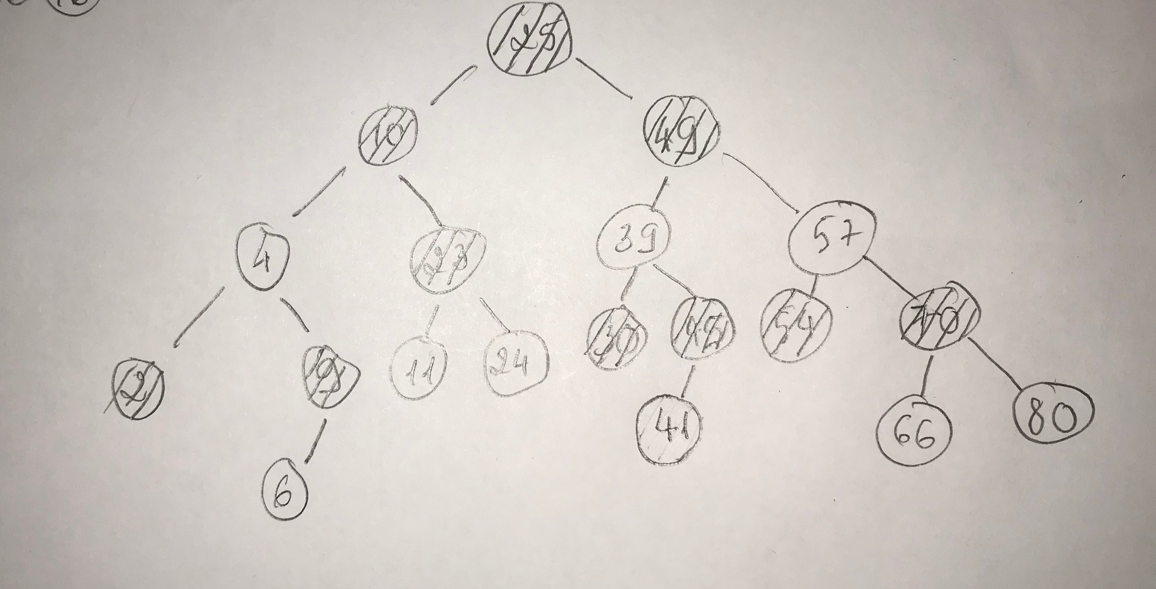This is the correspond Red Black Tree after delete 46:
* If option 3 is selected: A new random patient with distinct name and condition will be automatic created (Automatic random new patient to make sure that no patient has the same name and condition). This random patient will be inserted into the tree.
  + System will print out information of the newly created patient. The current tree after the insertion will also be printed. The color of the newly insert node will also be printed.
  + 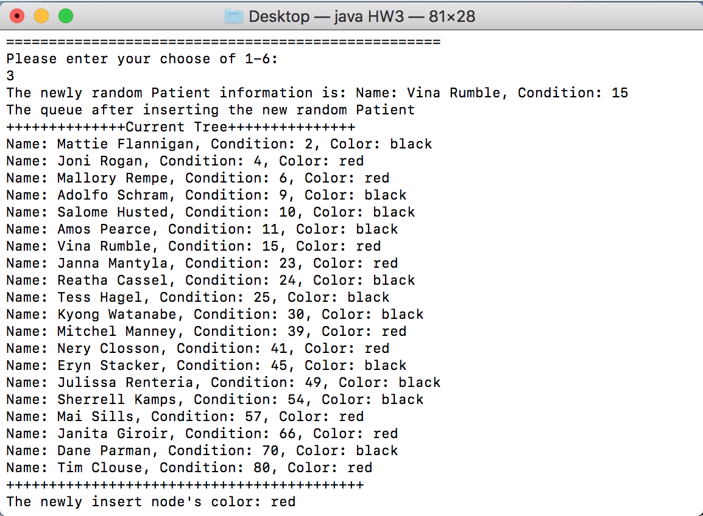Test Insert 1st time: Insert 15.
* 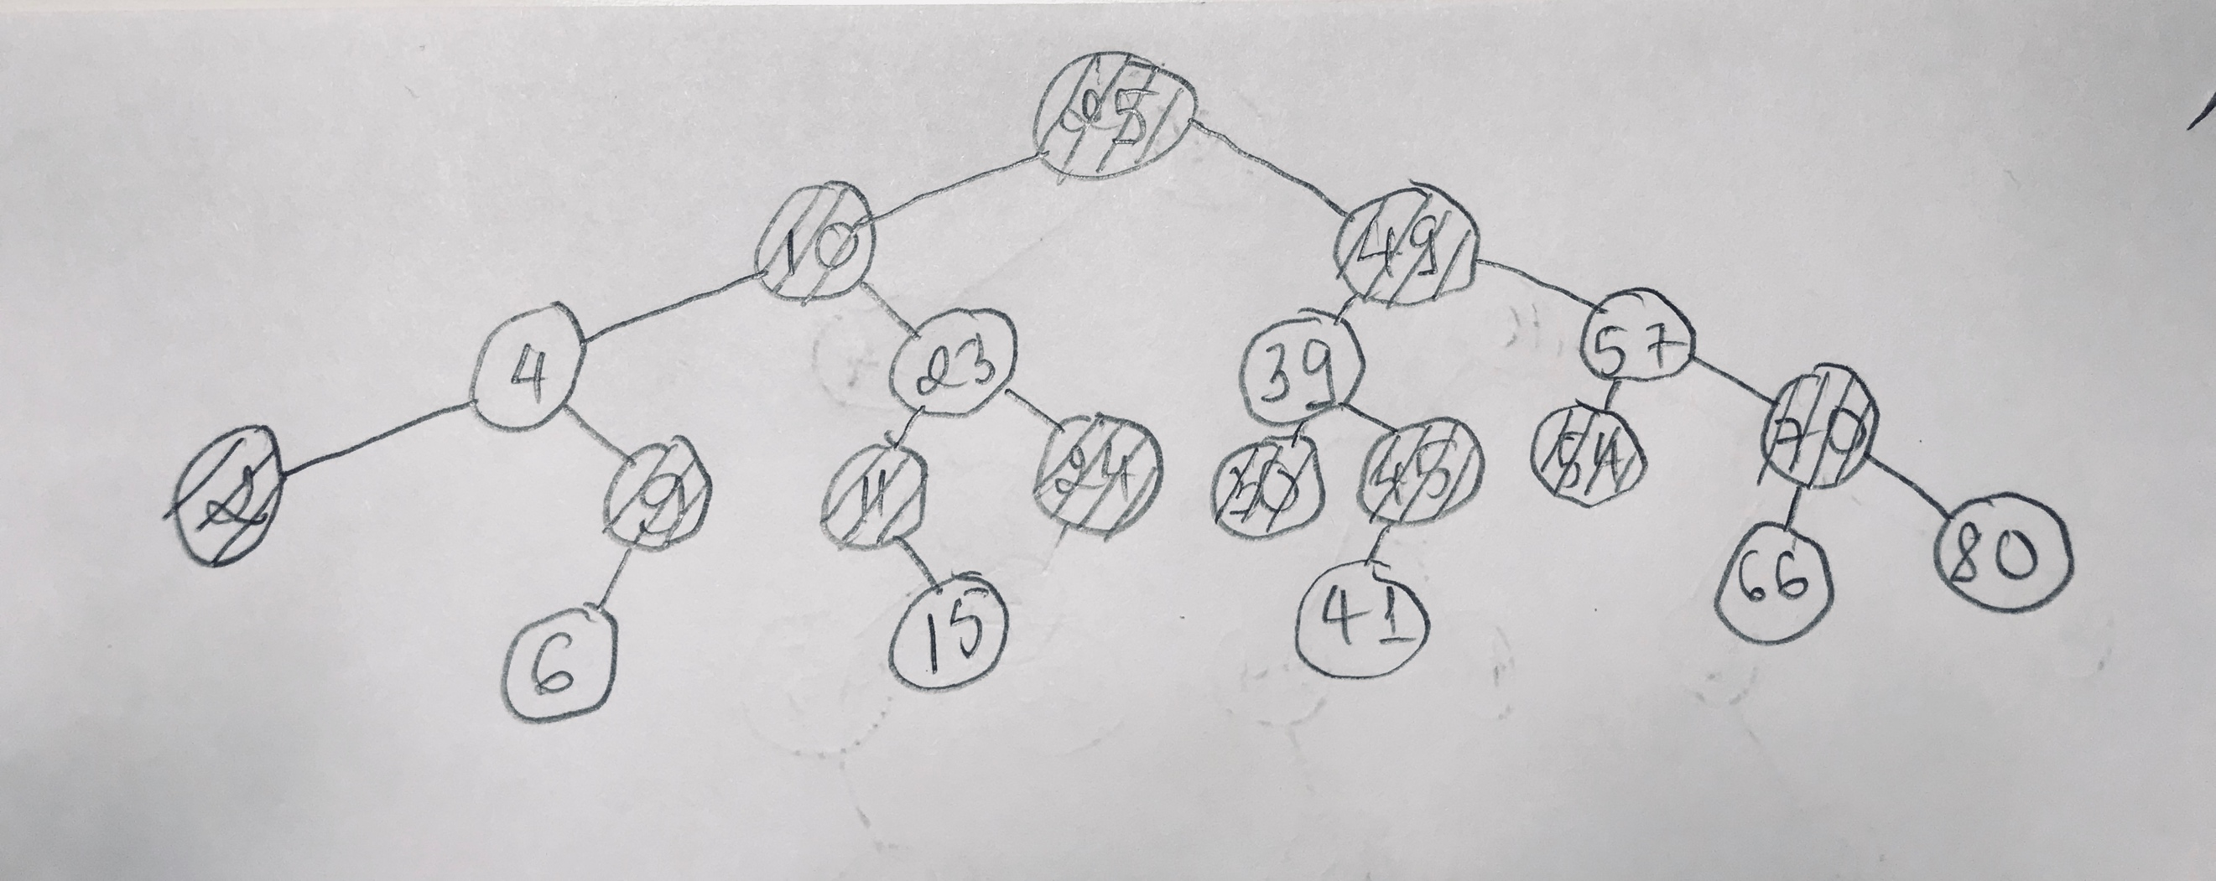Following is the corresponding draw of the current Red Black Tree after insert 15
* 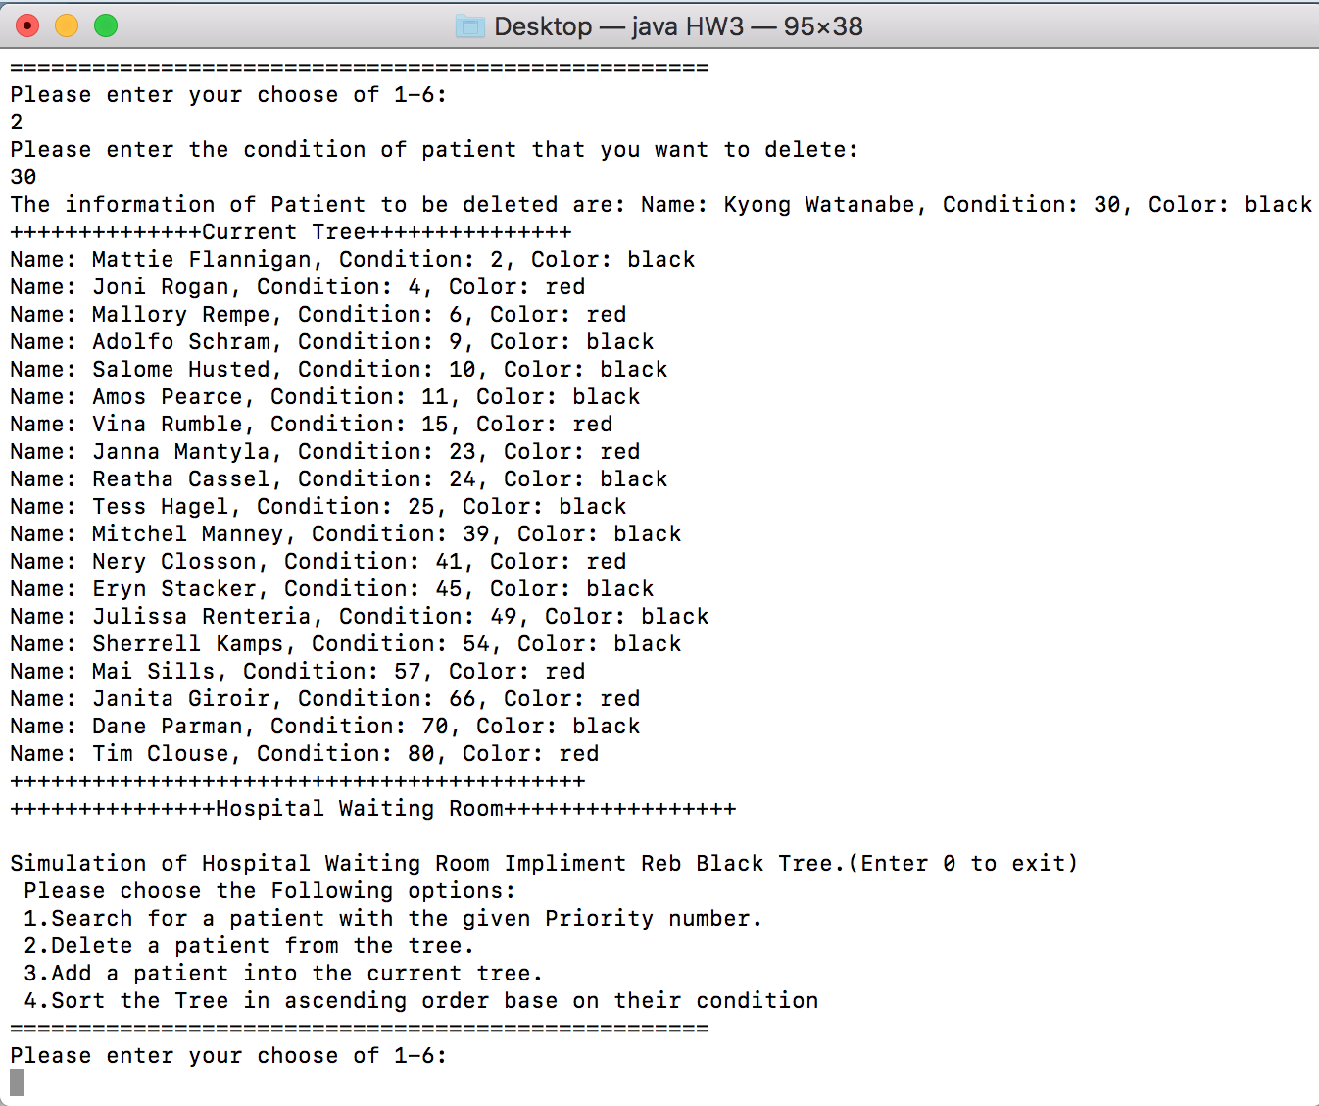Testing deleting 2nd time: Delete 30
* Following is the drawing of corresponding tree after delete 30:

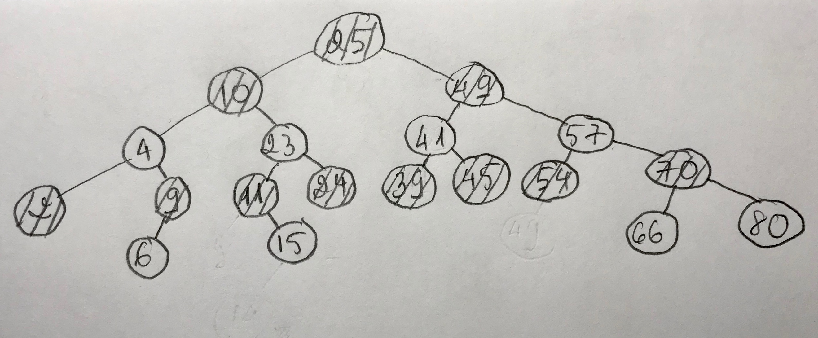

* Testing Insert 2nd time: Insert 14

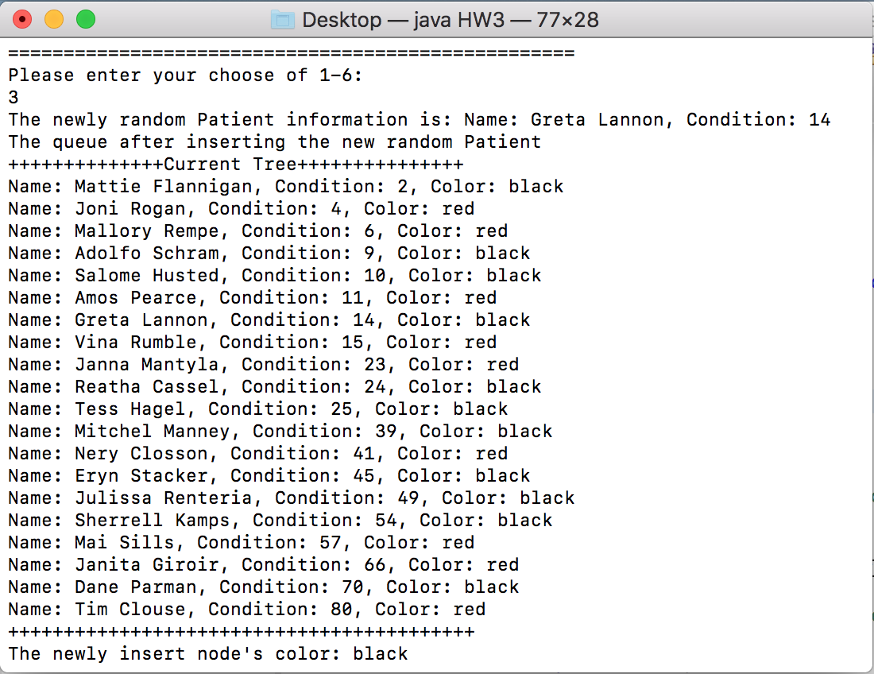

* The following is the corresponding Red Black Tree after Insert 14:

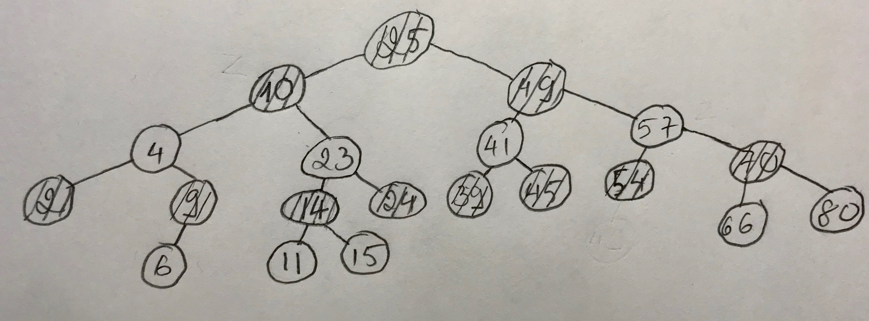

* Test Delete 3rd times: Delete 10

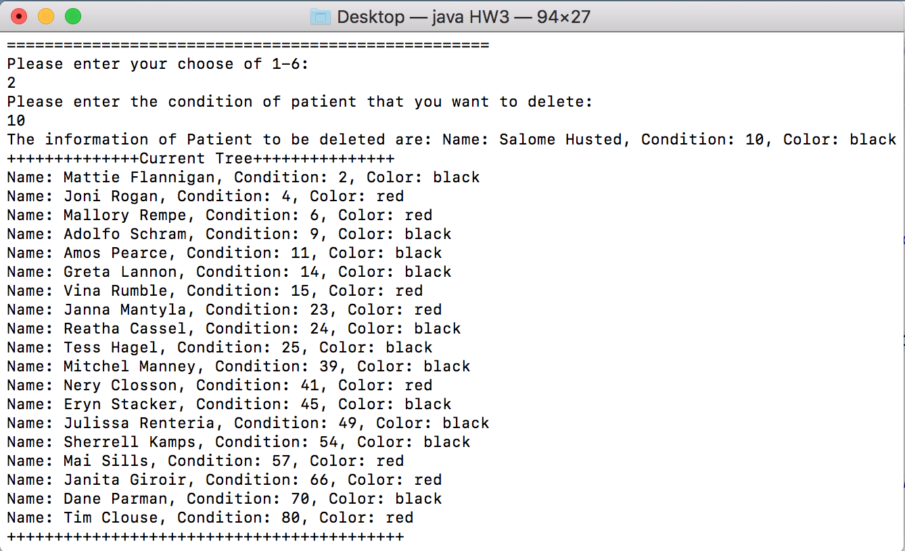

* 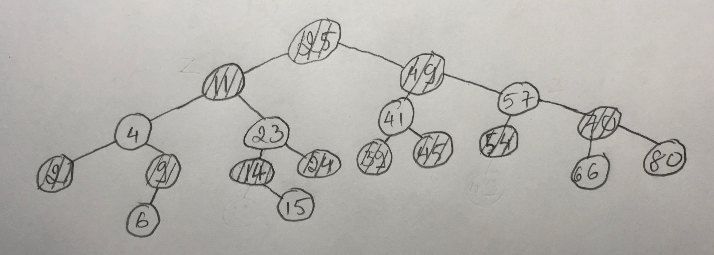Following is the corresponding Current Red Black Tree after delete 10:
* 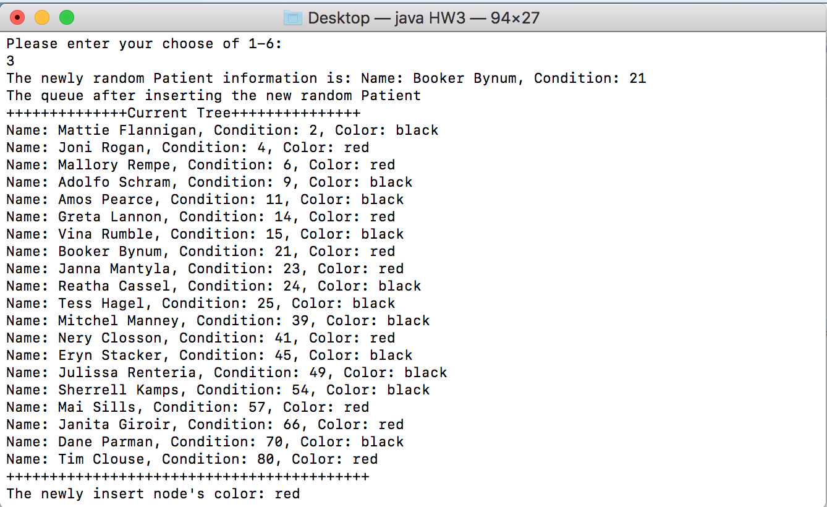Test Insert 3rd time: Insert 21.

- Corresponding Red Black Tree after insert 21:

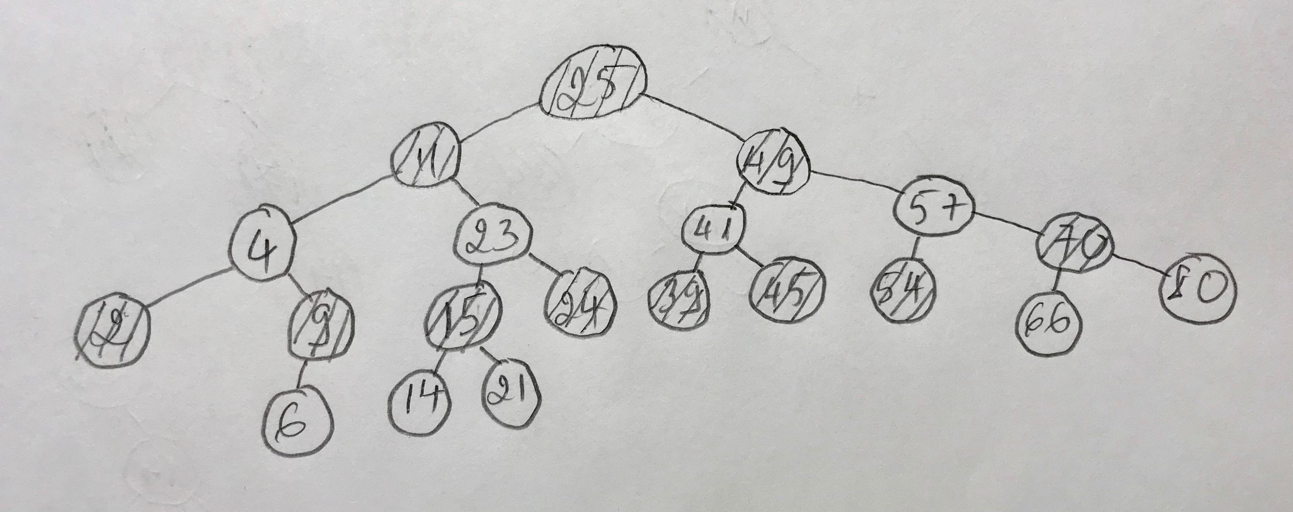

* 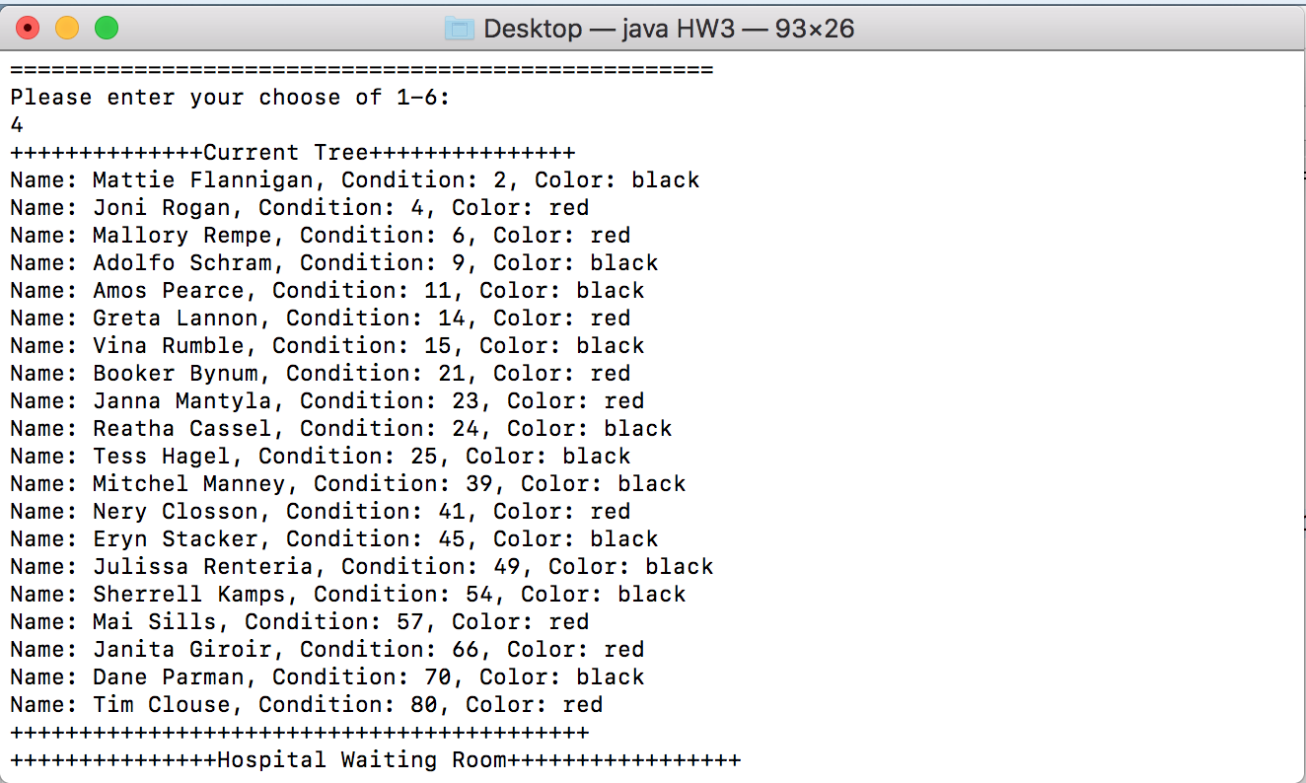if User choose option 4: The current Red Black Tree will be printed in ascending order base on their condition as follow:

1. How to unzip and run the program:

* Download the zip file named Le-PA3.zip and place in on your desktop.
* Unzip the file will create a folder named Le-PA3.
* Copy and Paste the .java file named HW3.java onto your desktop.
* Open your terminal (Or command line if you are using window).
* This window will appear:

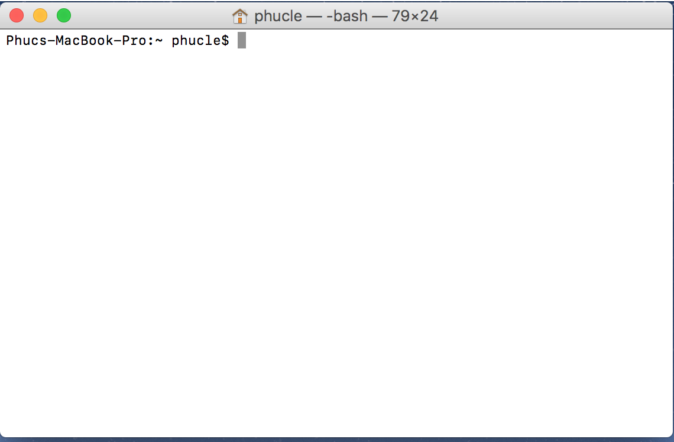

* 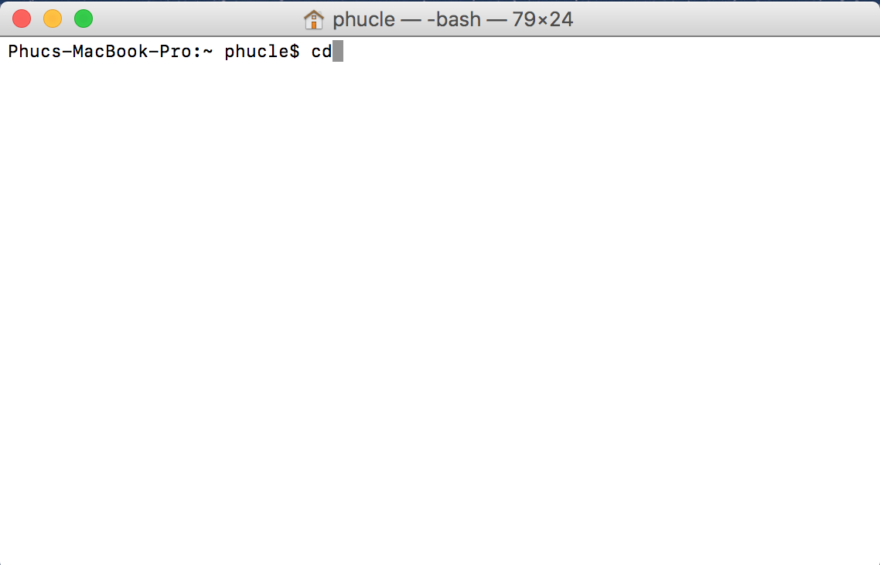Type “cd” then enter.
* 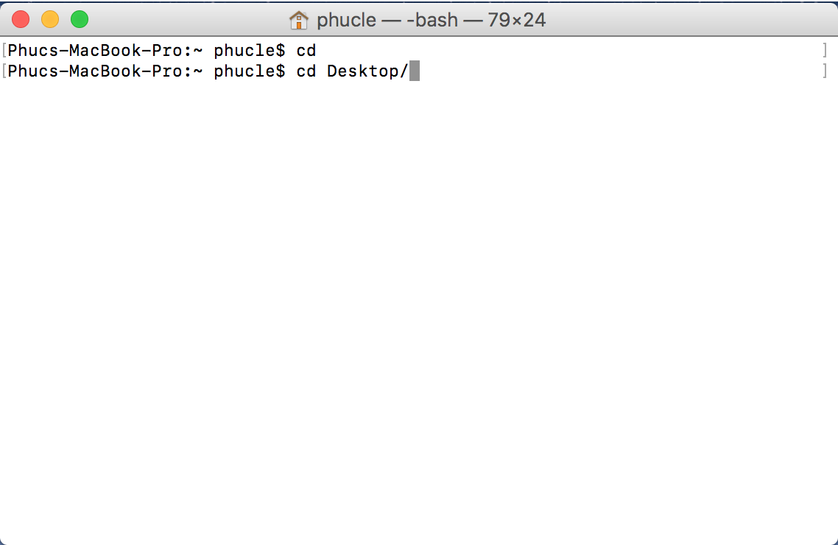Type “cd Desktop/” then enter.
* Type “java –version” to check if your computer has installed the Java SE runtime environment. If you see the below screen you are Ok. If you are not seeing this screen please download the Java RE and JDK, which can be found here:

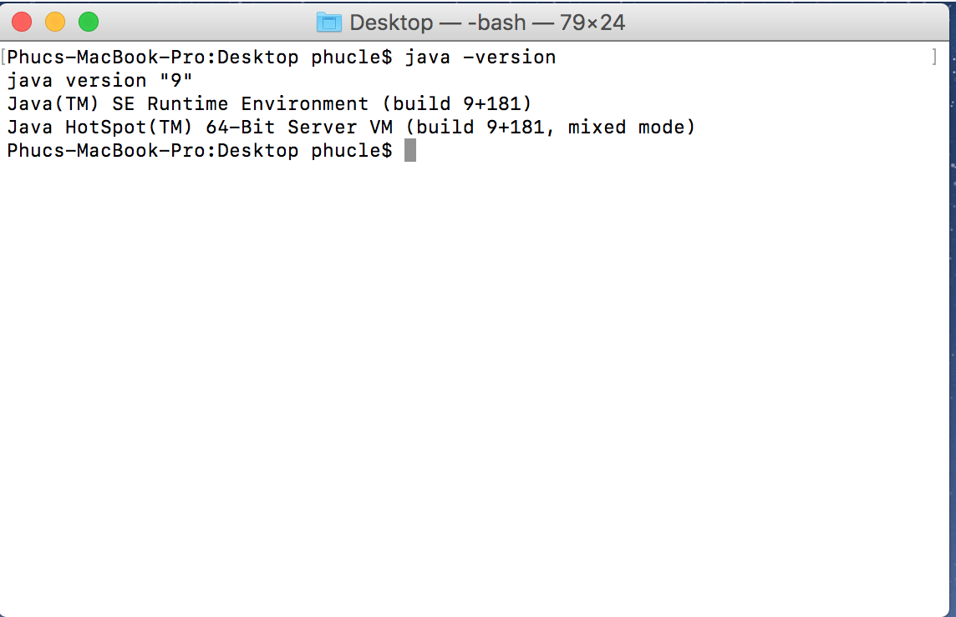<http://www.oracle.com/technetwork/java/javase/downloads/jre8-downloads-2133155.html>

* Type “javac HW3.java” and enter, then type “java HW3” and enter. The program should be running now and the following window will appear:

1. Problems encountered during the implementation.

* Red Black Tree Node Class require the nil node which has the “Black” color.
* The condition that user input has to be valid and the program will continues asking for valid condition.
* The waiting room can only store 20 patients, If User trying to insert new patient when the room is full. User has to delete one patient before insert.
* Red Black Tree Insert-Fixup and Delete-Fixup has to consider 2 symmetric cases.

1. Lesson Learned.

* Understand how to use the Red Black Tree and their Node as well as their properties, which help this data structure has log(n) complexity.
* Understand how to store actual value inside a node of Red Black Tree as well as Binary Tree. How to interact with the information inside the node.
* Learn how to create a Patient Array with different values of name and condition.
* Understand how the Property of the Red Black Tree work together.
* Review on using comparator class.
* Learned how to create a friendly User Interface.